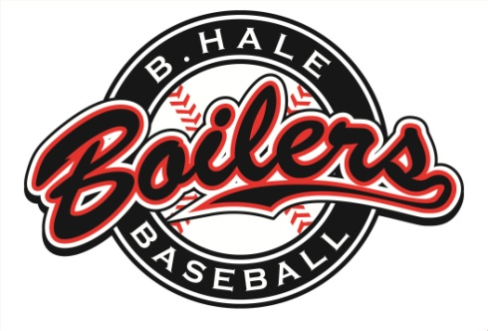
B. Hale Boilers Baseball

To Whom It May Concern:

On behalf of the Boiler’s Pony League Baseball Team, I am kindly requesting that you would make a contribution to our 8th Annual Boilers Golf Outing. This year’s event will take place on October 2, 2016. The donation could be an item given as a door prize for our use in our silent auction. We would also gladly accept any monetary contribution. The proceeds from this event will benefit the Boilers’ as they continue their quest to bring a Pony League World Series Championship to Johnstown. The Boiler franchise has advanced to the Pony World Series seven times, and hopes to continue this trend in the future. Additionally, the Boilers have begun awarding an annual scholarship at our Golf Outing to former players that have gone on to be successful students and citizens as they continue their baseball careers at the collegiate level.

Thank you in advance for your consideration of a donation and for supporting this event. If you would like more information regarding this event, please go to our website at www.bhaleinc.com. From there, click on the Baseball icon and find the Golf Outing information on the Alumni page.

DONATION TYPE ____________________________________
DOLLAR VALUE ____________________________________
SIGNATURE OF PERSON REQUESTING DONATION ____________________________________

PLEASE USE THIS PAPER AS YOUR TAX DEDUCTIBLE RECEIPT
YOUR GENEROSITY WILL BE RECOGNIZED IN OUR GOLF OUTING PROGRAMS.
THIS YEARS EVENT IS SCHEDULED FOR OCTOBER 2nd AT CHAMPION LAKES GOLF COURSE.

