Player 1___ Player 1________________
TEAM REGISTRATION
FORM
Address________________
Email_________________
Player 2________________
Address________________
Email_________________
Player 3_____________________________
Address_____________________________
Email ______________________________
Player 4 ____________________________
Address_____________________________
Email______________________________

Registration Deadline: September 24th
Make Checks Payable to Boilers Baseball
Mail To: Brian Hale
415 Vickroy Ave
Johnstown, PA 15905

Registration form can be printed off of Boiler website at bhaleinc.com

Brian Hale
415 Vickroy Ave
Johnstown PA 15905

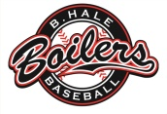
(814) 525—0599
brian@bhaleinc.com
B. Hale Boilers
Baseball

6th Annual Hall of Fame Golf Classic
Sunday October 4, 2015

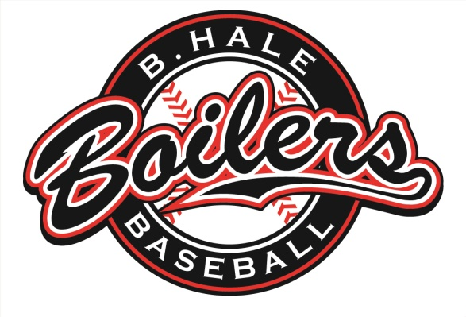
CHAMPION LAKES
GOLF CLUB
4743 ROUTE 711
BOLIVAR, PA 15923

Schedule of Events
11:00am-12:15pm
Registration and Lunch

12:30pm
Shot Gun Start

5:30pm
Dinner and Induction Ceremony

Prizes
Skill Prizes (Long Drive, Put, etc.)

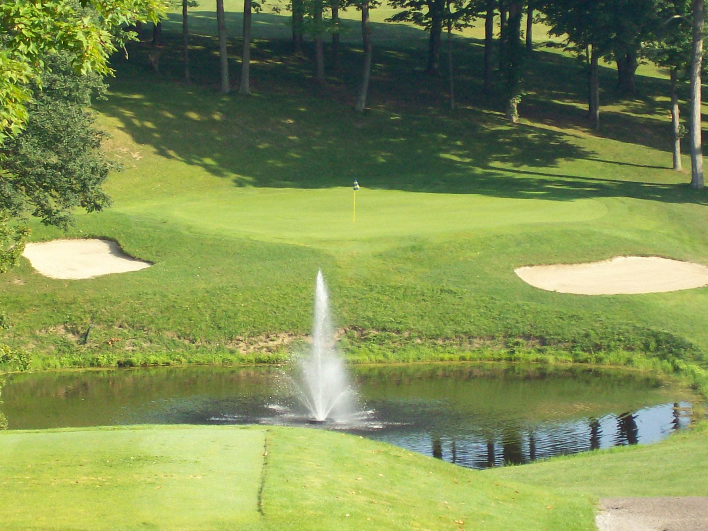
Fairway #11, Champion Lakes Golf Course

Winning Teams
Silent Aucton , 50/50, & Raffle Prizes
**Best Ball Scramble Format

Welcome

On behalf of the B.Hale Boilers Baseball Club, we would like to cordially invite you to take part in our 6th Annual Golf Tournament. We would like to thank you in advance for supporting our tournament and hope to see you on October 4th!

Participant Fees

Foursome - $330.00/Foursome registered together ($300.00/Foursome for current or former Boiler play-ers in the same foursome)

Participant - $90.00/Golfer. ($80.00 for current or former Boiler players)

Includes: Green fees, Golf cart, Registration, Light lunch, Beverages, Dinner and Awards ceremony.

** Tournament open to the first 92 golfers.

Sponsorship Levels

Corporate Sponsor - $500.00 Includes Company name on website, program recognition, and 1 team of four.

Lunch Sponsor - $425.00 Includes program recogni-tion, and 1 team of four.

Beverage Sponsor - $425.00 Includes program recog-nition, and 1 team of four.

Tee Sponsor - $100.00 Includes sign displayed at tee, and program recognition.

Kevin Coleman Scholarship Fund - Donation goes directly into a fund for former players college scholar-ship opportunities.

(Go To Boilers Alumni section on Website to preview last years levels)

Company Name:__________________________
Sponsorship Level:_________________________
Donation:________________________________
Dinner Only $30.00/person:_________________
(Includes dinner, ceremony, and beverages)

Brian Hale
415 Vickroy Ave
Johnstown PA 15905

brian@bhaleinc.com

Brian Hale (814) 525—0599
Champion Lakes Golf Club
4743 Route 711
Bolivar PA 15923

