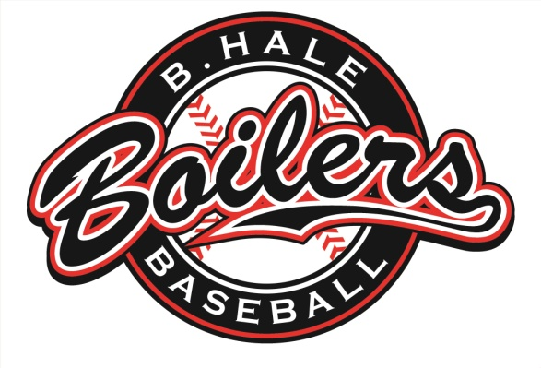
After 17 seasons – 160 players to wear the uniform – 15 consecutive city championships –
9 Pony League World Series appearances - ONE DYNASTY

The B.Hale Boilers have retired their Pony franchise.

Schedule of Events

Check-in
11:45 - 12:15

Shotgun Start
12:30

Dinner & Farewell Ceremony
5:45

Registration Deadline: September 30th

Send registration to:
Brian Hale
415 Vickroy Ave
Johnstown, PA 15905

Cost: $70.00 per person

*Includes golf, cart, dinner, and hot dog at turn.
*Dinner only-$20.00
* Beverages sold by Champion Lakes at a discounted price for participants.
* Skill prizes
* Make check out to Boilers Baseball

The format will still be a best ball scramble.

*If there are enough foursome groups representing former Boiler players and parents, we will have a separate contest for those participants.

Registration form attached

Player 1 _________________________________________________

Player 2 _________________________________________________

Player 3 _________________________________________________

Player 4 _________________________________________________

Registration Deadline: September 30th

Make checks payable to: Boilers Baseball

Mail to: Brian Hale
415 Vickroy Ave
Johnstown, PA 15905

